Vitis SW development demo: <https://www.youtube.com/watch?v=Ns6yOsQ2jvk>

GitHub:

* Squared Difference Accumulate Using Vivado High-Level Synthesis: <https://github.com/Xilinx/HLx_Examples/tree/master/Math/squared_difference_accumulate>

HLS Programming with FPGAs ([playlist](https://www.youtube.com/playlist?list=PLf4U4tpbjjz7x_bsG3sBEuXgVQPZfWJgW))

* **Part01** Introduction (HLS Programming with FPGAs): <https://youtu.be/6Jn8Vj3Hk5Y>
* **Part02** AWS F1 (HLS Programming with FPGAs): <https://youtu.be/Y2Crd-9kcYM>   
  GitHub aws/aws-fpga: <https://github.com/aws/aws-fpga> 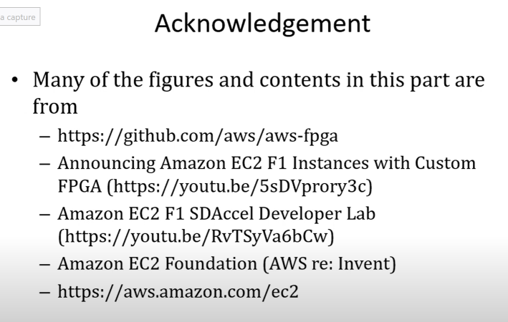
* **Part03** AWS HelloWorld (HLS Programming with FPGAs): <https://youtu.be/EnUFj5zWpUU>   
  GitHub: <https://github.com/aws/aws-fpga/blob/master/Vitis/README.md>
* **Part04** FIR1 (HLS Programming with FPGAs): <https://youtu.be/arazRaGvJtM>   
  Parallel Programming for FPGAs (book): <https://kastner.ucsd.edu/hlsbook/>   
  PP4FPGAs: Projects and Labs: <https://pp4fpgas.readthedocs.io/en/latest/index.html#>   
  Project: FIR Filter Design: <https://pp4fpgas.readthedocs.io/en/latest/project1.html>   
  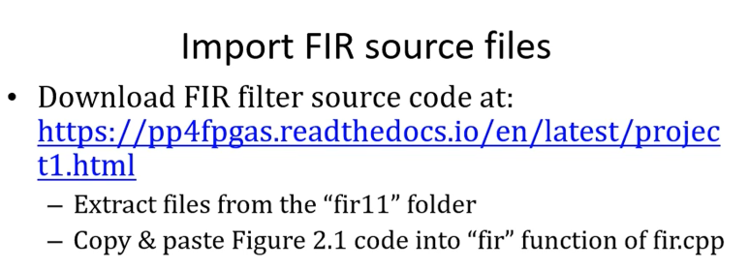  
  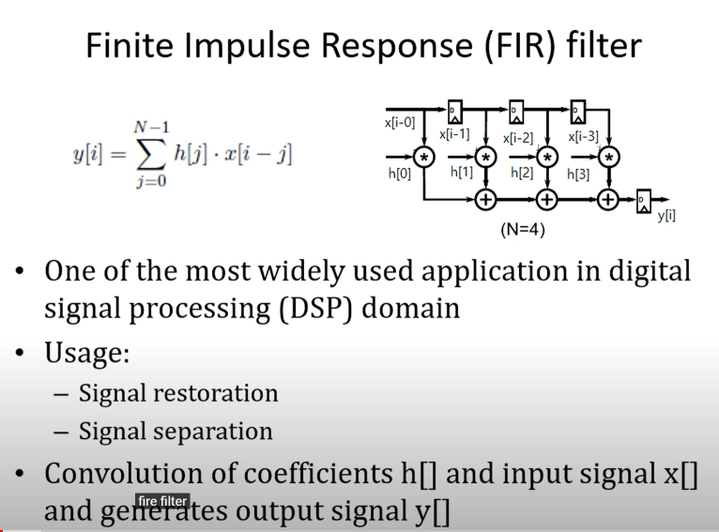  
  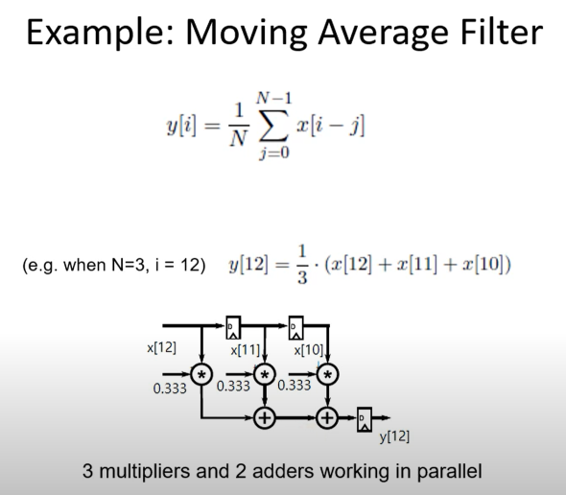  
  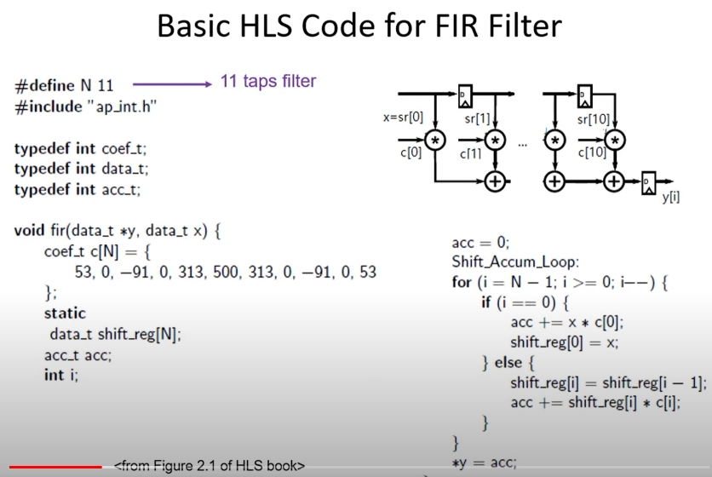
* **Part05** FIR2 (HLS Programming with FPGAs): <https://youtu.be/7lkMgzMTXQw>   
  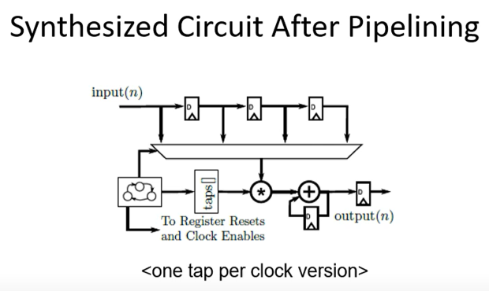
* **Part06** Vitis and VitisHLS (HLS Programming with FPGAs): <https://youtu.be/Ib3blx2Us8o>
* **Part07** CORDIC1 (HLS Programming with FPGAs): <https://youtu.be/Dq1B0YpzUak>
* **Part08** CORDIC2 and Fixed Point Representation (HLS Programming with FPGAs): <https://youtu.be/OHfNwTc8s90>
* **Part09** CORDIC3 and Fixed-Point Optimization (HLS Programming with FPGAs): <https://youtu.be/7C4v4vs2nFQ>

Amazon EC2 F1 Instances -- Enable faster FPGA accelerator development and deployment in the cloud: <https://aws.amazon.com/ec2/instance-types/f1/>